**Observation**

Inspection was undertaken at the subject property in the presence of the Insured to which the following was noted:

## Received Documentation

1. We acknowledge receipt of the sewer & stormwater mark-up diagram (and survey) shown as ***Figure 2*** below.

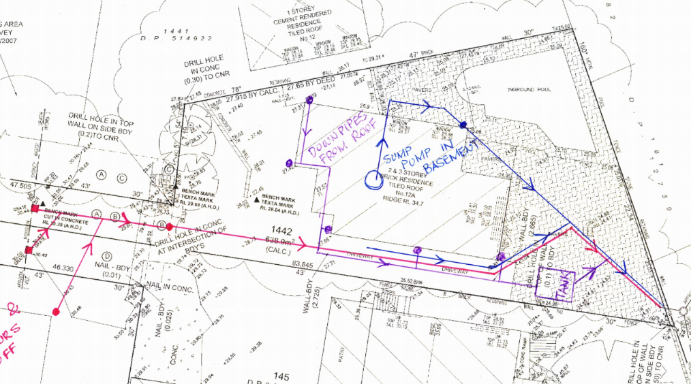

***Figure 2: Sewer & Stormwater Mark-up (and Survey)***

1. We have further received Dial Before You Dig Sydney Water Services to confirm the above mark-up which has been attached as ***Appendix A***.

## Observations

### Boundary Retaining Wall

1. Our inspection was generally undertaken within the property confinements of 27 Allawah Avenue; however, we note that the subject retaining wall also forms part of the rear boundary of 25 Allawah Avenue, 12A Gnarbo Avenue & 14A Gnarbo Avenue.
2. We note that the boundary retaining wall, which is located about the South-Western boundary of 27 Allawah Ave has partially collapsed. **Image 3 – 5**
3. From our on-site measurements, the length of the collapsed retaining wall is approximately 12Lm in length.
4. The construction of the subject boundary retaining wall consists of the following elements:
5. Original sandstone retaining wall which reduces in height along the northern alignment of the retaining wall. **Images 6 – 8**
6. Approximately 1m high 230mm thick solid brick retaining wall constructed off a concrete footing above the existing sandstone retaining wall (pertaining to 12A Gnarbo Avenue). **Images 9 – 10**
7. We note that the average retaining wall height was approximately 2m along the length of the collapsed wall. **Image 11**
8. From review of the survey plan, the top of the wall RL is shown as *25.03*, and the rear yard of 12A Gnarbo Ave having an RL of *24.9*, which indicates that the brick wall was retaining soil up to a height of approximately 130mm below the top of the wall (or a retained soil height of approximately 1.9m).
9. From inspection of the collapsed soil behind the subject retaining wall, we confirm that we did not observe any subsoil drainage or free-draining material. **Images 12**
10. We also have undertaken inspection of the remaining sandstone retaining wall still intact adjacent to the collapsed retaining wall to which we noted cracking, erosion and movement to the wall. **Images 13 – 14**
11. We further noted large trees in close proximity to the northern alignment of the subject retaining wall. **Image 15**

### Sewer Service

1. The Insured advised that as a result of the retaining wall failure that the sewer line servicing 12A Gnarbo Ave was damaged, to which temporary infrastructure has been installed to service 12A Gnarbo Ave. **Image 16**
2. The Insured advised that they did not note any sewerage smell prior to the collapse of the retaining wall.

### Additional Concerns

1. During our inspection, the Insured also advised that since the collapse of the subject retaining wall additional surface water has flowed onto the subject property which has caused the following to occur:
2. Sandstone garden edging to dislodge and collapse. **Images 17 – 18**
3. Water ingress within the lower-level garage of the subject property. **Images 19 – 20**
4. From inspection within the subfloor adjacent to the garage, we note that the soil was generally damp on the surface adjacent to the external brick dwarf wall. **Image 21**
5. We further confirm that we did not observe any subsoil, drainage within the subfloor area, or surface drainage adjacent to the subfloor area.

**Discussion**

## Retaining Wall Age & Condition

1. We have undertaken review of historical imagery from the NSW government Website, to which it is evident that the construction of the subject Sandstone retaining wall was undertaken circa 1960’s during subdivision of the adjoining land.
2. Given the above, we estimate that the subject original stone retaining wall is in excess of 50 years in age to which the retaining wall construction pre-dates the inception of the BCA and AS4678-2002 Earth-retaining structures.
3. As outlined above, the adjacent intact stone retaining wall was evidently in a cracked and eroded state, which in our opinion, is a result of long-term weather exposure and gradual tree root growth below the subject retaining wall.
4. Based on the age and condition of the remaining intact stone retaining wall, in our opinion, the stone retaining wall has surpassed its serviceable design life.
5. Notwithstanding the above, it is evident that the brick retaining wall was constructed after the construction of the Sandstone retaining wall to level the rear yard of 12A Gnarbo Avenue.
6. From review of the subject brickwork retaining structure, we estimate that the retaining wall was constructed circa 1980’s and also pre-dates the inception of the BCA and AS4678-2002 Earth-retaining structures.

## Neighbouring Stormwater Runoff & Drainage

1. The Insured has raised concerns regarding neighbouring stormwater runoff, which they believe is the underlying cause of failure of the subject retaining wall.
2. Notwithstanding the above, we have undertaken review of the neighbouring stormwater drainage based solely from inspection within 27 Allawah Avenue and review of the survey.
3. From review of the survey, we note that the rear yard of 12A Gnarbo Avenue has one (1) 470mm deep stormwater pit to collect stormwater runoff throughout the entire yard of 12A Gnarbo Avenue.
4. We are not privy to the details of the subject stormwater pit, nor did our inspection include for a detailed assessment of the stormwater drainage within 12A Gnarbo Avenue as our access was limited to 27 Allawah Avenue.
5. However, as noted above, we did not observe any subsoil drainage behind the subject retaining wall, which is essential in alleviating hydrostatic pressure build-up behind the retaining wall system, which is described within *AS 4678-2002 Clause 3.6* (see ***Figure 3*** below).

***Figure 3: Extract from AS4678-2002 (Clause 3.6 Drainage)***

1. Based on our observations, in our opinion, the observed surface & subsoil drainage provisions behind the retaining wall were insufficient to alleviate the build-up of hydrostatic pressure behind the subject retaining wall.

## Stormwater/Sewer Contribution

1. We have undertaken assessment of whether the water services located behind the subject wall had any bearing on the wall failure.
2. However, as the Insured has stated, they did not note any sewer smell prior to the wall collapse.
3. Furthermore, we did not observe any localised erosion which we would expect to occur should localised breakage within a sewer/stormwater occur.
4. Based on the above, in our opinion, the retaining wall failure has not been caused by a breakage within stormwater/sewer services located behind the subject wall, but rather the retaining wall failure has led to damage to the services located behind the subject retaining wall.

## Experienced Rainfall

1. From review of Nearmap imagery, we note that the claimed date of loss is in-line with the Insureds provided advice (see ***Appendix B***).
2. As such, we have undertaken review of the Rainfall data collected at the Bureau of Meteorology Peakhurst Golf Club Station (which is located approximately 6km from the subject property) for March 2021, see ***Appendix C***.
3. From review of the Rainfall data, we note that between 19 March 2021 and 24 March 2021, approximately *334mm* of rainfall was recorded.
4. Such amount of rainfall and absence of sufficient surface and subsoil drainage behind the subject retaining wall will result in a significant increase in the hydrostatic pressure imposed onto the subject retaining wall.

## Proximate Cause of Retaining Wall Failure

1. From review of the failure pattern observed at the time of our inspection, in our opinion, the sandstone retaining wall has failed which has caused the retained soil to become unstable and subsequently *‘slump’*.
2. In our opinion, the slumping of the soil has caused the upper brick retaining wall to become undermined and subsequently rotate and fail as well.
3. Based on our on-site observations, in our opinion, the following are the underlying contributing factors to the retaining wall collapse:
4. Omission of sufficient surface and subsoil drainage which has allowed build-up of hydrostatic pressure behind the subject retaining wall.
5. Long-term deterioration of the sandstone retaining wall which has ultimately compromised the structural integrity and stability of the retaining wall system.
6. In schematically illustrating the above-mentioned failure mechanism of the retaining wall, we provide ***Figure 4*** below.

***Figure 4: Proximate Failure Mechanism of the Subject Retaining Wall***

1. To this end, in our opinion, the underlying cause of the retaining wall failure is due to inherent construction issues and long-term deterioration of the stone retaining wall, to which the heavy rainfall in March 2021 has only triggered the inevitable failure of the subject retaining wall.

## Make-Safe Works & Reinstatement

1. At this stage, we confirm that the collapsed debris is currently in a stable condition, however recommend that the debris be removed as soon as practical.
2. However, the exposed soil face is at risk of erosion, to which we recommend that the soil face be protected through the installation of waterproof tarpaulin and tie-downs to divert stormwater during heavy rainfall.
3. Notwithstanding the above, the boundary wall between 12A Gnarbo Avenue & 14A Gnarbo Avenue is currently partially undermined. **Image 22**
4. Given the above, we recommend that the unsupported retaining wall be temporarily propped and braced until permanent rectification works are able to be undertaken.
5. We note that the subject retaining wall be will required to be reconstructed, which will require a Development Approval and Structural design which has been outlined within the ***Recommendations*** section of this report.

## Retaining Wall Ownership, Liability and Benefit

*We advise that Silver Wolf Projects* ***is not qualified*** *to provide legal advice on retaining wall ownership and liability as this relates to common law practice and is for* ***guidance only*** *and is to be formally verified by a practicing Solicitor.*

1. In providing recommendation in retaining wall ownership, we have investigated possible defining parameters in both retaining wall and fence constructions.
2. From our review, the subject retaining wall and supported boundary fence have been constructed on the common boundary line between the Insured’s property and neighbouring properties at 25 Allawah Avenue, Carss Park, 27 Allawah Avenue Carss Park & 12A Gnarbo Avenue Carss Park.
3. We further note that the stone retaining wall extends along the common boundary between 27 Allawah Avenue Carss Park & 14A Gnarbo Avenue Carss Park.
4. In illustrating the location of the retaining wall along the boundaries of the abovementioned properties, a schematic annotated plan has been provided in ***Figure 5***.

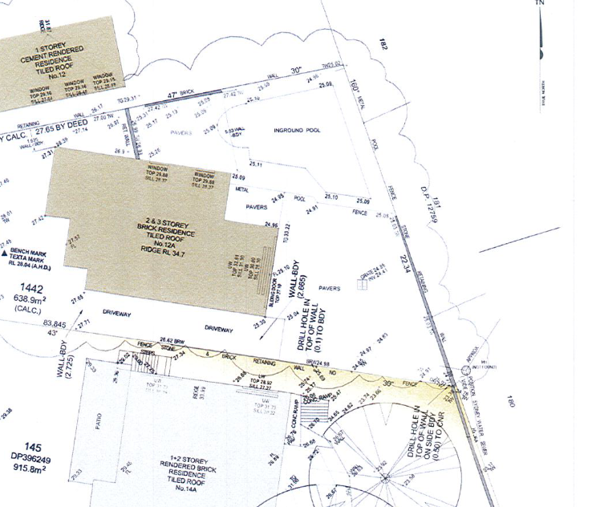

25 Allawah Ave

27 Allawah Ave

14A Gnarbo Ave

12A Gnarbo Ave

***Figure 5 – Schematic Location of Retaining Wall Along Property Boundaries***

1. From our research which has been obtained through *Legal Services Commission of South Australia*, there is no conclusive legislative document to rule the liability of the adjoining owners relative to retaining wall construction and maintenance along the property boundaries.
2. It is our understanding that law concerning retaining walls is principally conducted under common law of nuisance and, where retaining walls were constructed after 15 January 1994, under the Development Act 1993.
3. In determining the ownership, liability and benefit of all parties, we provide the following qualifications.
4. Given the location of the retaining wall along the common boundary line, in our opinion, the Insured, the Owners of 12A & 14A Gnarbo Ave, Carss Park and the Owner of 25 Allawah Ave, Carss Park all have ***ownership*** of the wall.
5. However, ***liability*** of a retaining wall is defined by its ***benefit*** with respect to the requirement or need to support or retain fill for the purposes of development due to altering the natural state of the land.
6. Benefit of the retaining wall is where it is constructed to enable the Owner to preform building works that affects the stability of the adjoining land and is required to support change in the natural state of land.
7. Notwithstanding the shared location about the boundary alignment, ***benefit*** of the retaining wall was for the retention of soil within 12A Gnarbo Ave, Carss.
8. On the basis of the above, in our opinion, we envisage that the Owner of 12A Gnarbo Ave, Carss Park would be responsible for the majority of the incurred cost in the rectification works to the subject retaining wall.

## Additional Concerns

### Garden Edging & Water Ingress in Basement

1. Whilst we note that the retaining wall failure will facilitate additional water flow onto the Insured property, in our opinion, the increased water flow will not be sufficient to result in the observed collapsed of the sandstone garden bed edging.
2. In our opinion, the garden bed edging has become dislodged over an extended period of time due to vegetation growth behind the edging, to which stormwater runoff has only triggered the collapse of the sandstone edging.
3. As such, in our opinion, the observed dislodgment of the sandstone is unrelated to the collapse of the subject retaining wall.
4. Furthermore, as noted above, we did not observe any surface or subsoil drainage to mitigate water ingress within the subfloor.
5. We confirm that we did not observe any resultant damage within the garage, to which the Insured advised that they had patched sections of the concrete garage walls in attempt to mitigate future water ingress.
6. Notwithstanding the above, in our opinion, the water ingress within the garage is due to insufficient surface and subsoil drainage provisions to mitigate water ingress within the property subfloor and is unrelated to the collapse of the subject retaining wall.

**Conclusion**

We note that the subject retaining wall failure is common to the boundary of the following property:

1. 27 Allawah Avenue Carss Park & 12A Gnarbo Avenue Carss Park.
2. 25 Allawah Avenue Carss Park & 12A Gnarbo Avenue Carss Park.

The failed retaining wall consists of an original sandstone retaining wall with a brick retaining wall constructed on top of the stone retaining wall, to which the retained soil was approximately 130mm lower than the top of the brick retaining wall.

The failed section of retaining wall extends for an approximate length of 12Lm.

## Drainage Concerns

The Insured raised concerns regarding drainage on the neighbouring property, which is believed to have been the cause of the retaining wall failure.

We have undertaken assessment of the drainage based on our visual assessment within 27 Allawah Avenue, to which we confirm that we did not observe any evidence of subsoil drainage or surface drainage within the collapsed debris and soil behind the subject retaining wall.

Whilst we note that the age of the retaining wall pre-dated the inception of AS4678:2002, the drainage considerations outlined within this Australian Standards states that:

*“Drainage and the possible development of pore water pressure within a soil are amongst important considerations in the design of retaining structures because the presence of water behind an earth-retaining structure has a significant effect on the pressures applied to the structure. Even when there is no water in direct contact with the structure, increased pressures can occur on a retaining structure due to an elevated phreatic surface developed from water seepage into the failure wedge behind the structure.”*

Based on our visual assessment, in our opinion, the inadequate surface and subsoil drainage provisions behind the retaining wall has allowed the build-up of hydrostatic pressure behind the retaining wall which has contributed to its failure.

## Stormwater/Sewer Contribution

During our inspection, the Insured advised they did not note any sewerage smell prior to the collapse of the retaining wall.

Furthermore, we further confirm that we did not observe any localised erosion to the soil which we would have expected to observe should a breakage within the pipe infrastructure located behind the retaining wall have caused the observed collapse.

Based on the above, in our opinion, the retaining wall failure has not been caused by a breakage within stormwater/sewer services located behind the subject wall, but rather the retaining wall failure has led to damage to the services located behind the subject retaining wall.

## Experienced Rainfall

From review of Nearmap imagery, we note that the claimed timeline of the retaining wall collapse is in-line with the Insureds provided advice being around 23 March 2021.

From review of rainfall data from Peakhurst Golf Club for March 2021, we note that between 19 March 2021 and 24 March 2021, approximately *334mm* of rainfall was recorded.

Without adequate surface and subsoil drainage, the experienced rainfall would have resulted in a significant build-up of hydrostatic pressure behind the subject retaining wall.

## Proximate Cause of Retaining Wall Failure

From review of the subject retaining wall failure, it is evident that the lower sandstone retaining wall has failed, which has caused the retained soil to ‘*slump’* and the brick retaining wall to subsequently rotate and fail.

We have undertaken inspection of the intact sandstone retaining wall adjacent to the collapsed retaining wall to which we note that the wall is in a cracked and eroded state.

Such cracking and erosion are consistent with long-term weather exposure and gradual tree root growth below the subject retaining wall.

Given the above, in our opinion, the sandstone retaining wall was in a deteriorated and compromised condition prior to its collapse.

Based on our on-site observations, in our opinion, the following are the underlying contributing factors to the retaining wall collapse:

1. Omission of sufficient surface and subsoil drainage which has allowed build-up of hydrostatic pressure behind the subject retaining wall.
2. Long-term deterioration of the sandstone retaining wall which has ultimately compromised the structural integrity and stability of the retaining wall system.

To this end, in our opinion, the underlying cause of the retaining wall failure is due to inherent construction issues and long-term deterioration of the wall, to which the heavy rainfall in March 2021 has only triggered the inevitable failure of the retaining wall.

## Additional Concerns

During our inspection, the Insured raised additional concerns regarding additional stormwater runoff within the property which has been claimed to have resulted in the following:

1. Dislodgement of sandstone garden edging.
2. Water ingress within the basement.

Whilst we note that the retaining wall collapse would result in an increase of stormwater runoff on the subject property, in our opinion, this is insufficient in magnitude to result in the above-mentioned issues.

Based on the above, in our opinion, the dislodgement of the sandstone garden edging is due to long-term root pressure imposed from on-going gradual vegetation growth behind the edging and is unrelated to the subject retaining wall collapse.

Furthermore, in our opinion, the water ingress within the garage of the subject property is due to omission of sufficient surface and subsoil drainage about external garage wall which has allowed water to ingress through the wall during heavy rainfall.

Given the above, in our opinion, the water ingress within the garage is unrelated to the subject retaining wall collapse but rather a result of inherent construction issues.